Operating the Pressure Driven Flow Controller (PDFC)

[AaronDelahanty@gmail.com](mailto:AaronDelahanty@gmail.com)

05-SEP-2016

Contents

Setup 2

Power and Communication: 2

Pneumatic Supply Line: 2

Regulated Pneumatic Outputs: 4

Recalibration of the Pressure Regulators: 4

Operation 5

Recording of pressures 6

# Setup

## Power and Communication:

The system must be connect to both external power via the 240VAC->9VDC transformer, shown in figure 1 and to the PC via USB.

Figure 1: The inputs and outputs of the PDFC.

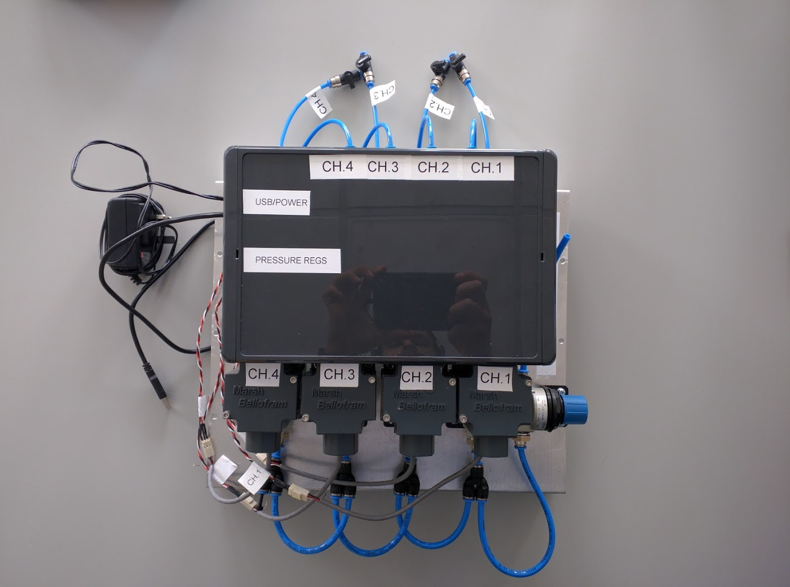

Power and USB

Regulated Pressure Outputs

Supply Pressure Input

## Pneumatic Supply Line:

The main pneumatic supply line should be connected to the safety pressure relief valve at the area labelled’ SUPPLY PRESSURE INPUT’, shown in figure 1. Leave the input valve closed until the compressor has come to pressure, and the LabVIEW interface is open and ready for use.

Turn on the air compressor and ensure that the output is set between 2 and 4bar using the regulator shown in Figure 2. It has been observed that cycling of the air compressor ON-OFF has no measurable effect on the output pressures provided by the PDFC. After each use, turn of the air compressor and release the pressure, shown in Figure 2. Occasionally monitor the oil level and the condensation filters on the air compressor, replace as needed.

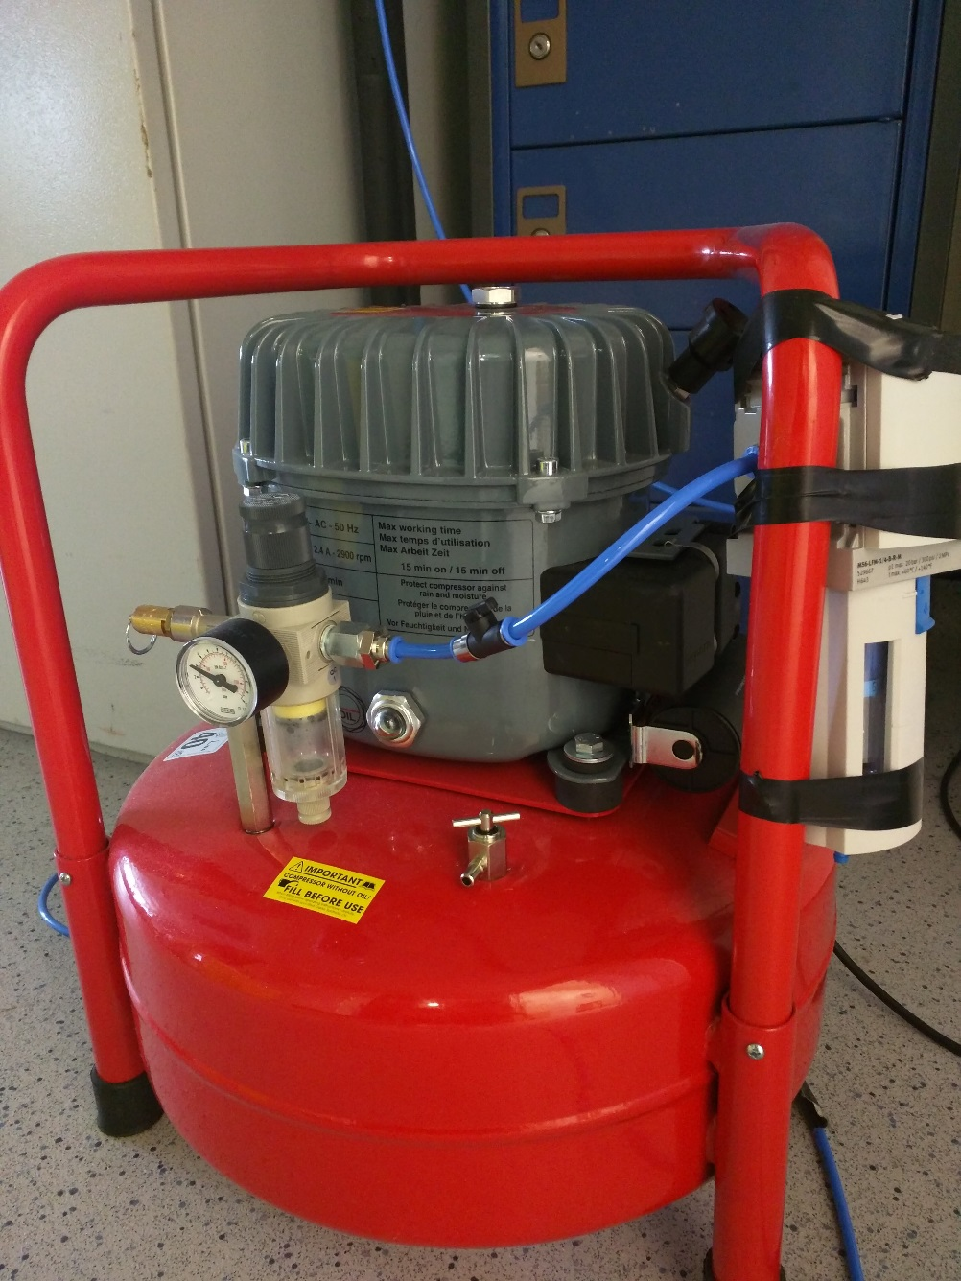

Air Compressor Regulator (Set between 2-4bar)

Pressure Release (Open after compressor is turned off)

Oil View Gauge

Condensation Filters

Figure 2: Air compressor and various elements.

## Regulated Pneumatic Outputs:

Each of the regulated outputs can be connected to reagent reservoirs as needed. Ensure lines not in use are closed, shown in figure 1.

## Recalibration of the Pressure Regulators:

Should the regulated pressure deviate significantly from the desired value written, each individual regulator can be calibrated by adjusting the zero, span, and gain potentiometers, shown in figure 4. Consult the *Marsh Bellofram T2000* Data sheet for further information.

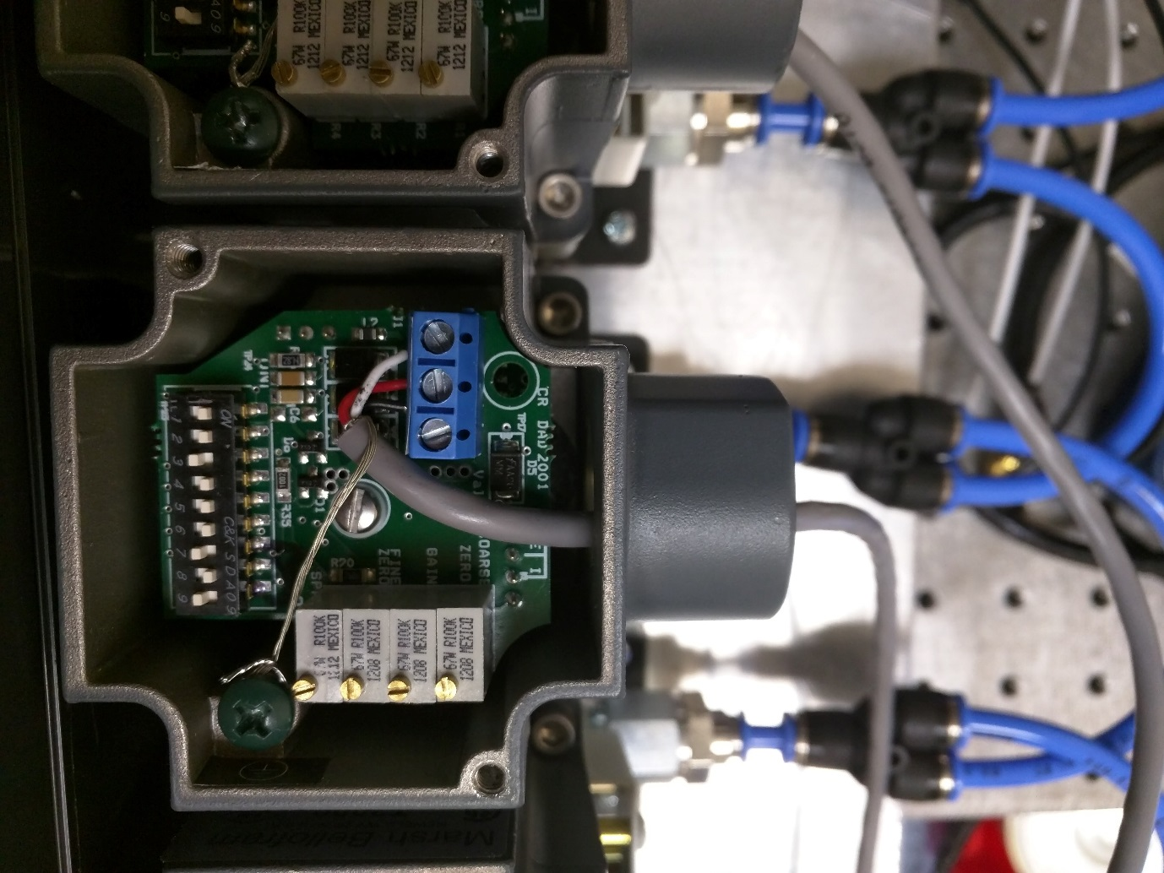

Coarse Zero

Span

Gain

Fine Zero

Figure 3: Marsh Bellofram T2000 calibration settings.

# Operation

After the PDFC is powered and connected to the PC via USB, the LabVIEW VI titled ‘PDFC*05092016.vi’,* can be opened. The current version of the controller can be found at the following directory:

*S:\Frankelab\Aaron PDFC\PDFC05092016 Folder*

And also on my personal github:

<https://github.com/aarondelahanty/EFC-development>

The Arduino status should show GREEN, indicating that the PC and PDFC are connected and that LabVIEW is capable of communicating with the PDFC’s microcontroller.

Set desired pressure, in mbar

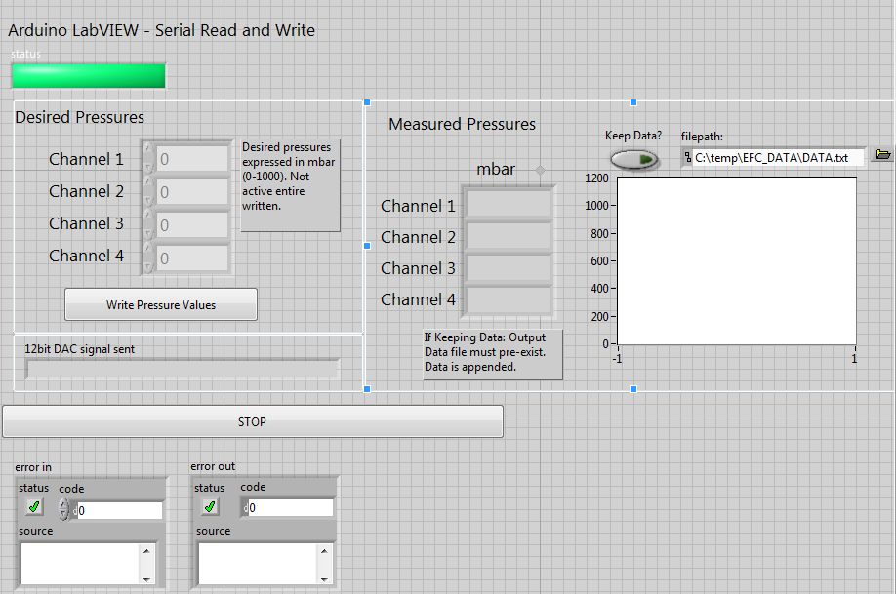

Write pressures by pressing this button

Measured pressures shown here

Set directory, and record data here

Figure 4: Frontend of LabVIEW VI

# Recording of pressures

Should you wish to record the measured output pressures the file directory can be set as shown in Figure 4. The outputs written to the data file include; the 4 measured pressure values, an arbitrary time stamp (in ms), and the binary string associated with control of the DACs and pressure regulators. The Binary string is composed of four 12-bit elements that linearly scale from 0 to 1000 mbar (i.e. 0 = 0mbar, 4095.0 = 1000mbar), shown in Figure 5. These six elements iterate for each read command issued by the LabVIEW interface.

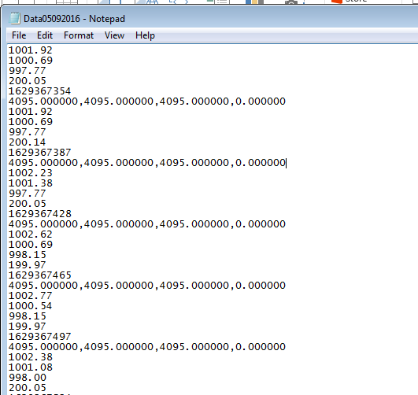

Measured Pressures (mbar)

Time stamp (ms)

Binary Pressure Command Sent

Figure 5: Example data output file.